**DAILY ONLINE ACTIVITIES SUMMARY**

|  |  |  |  |  |  |  |  |  |
| --- | --- | --- | --- | --- | --- | --- | --- | --- |
| **Date:** | **28/05/2020** | | | | | **Name:** | **Sathvik R Shetty** | |
| **Sem & Sec** | **6th /B** | | | | | **USN:** | **4AL17CS089** | |
| **Online Test Summary** | | | | | | | | |
| **Subject** | | **OS IA Test - 2** | | | | | | |
| **Max. Marks** | | **30** | | **Score** | | | **N.A(Technical Problem)** | |
| **Certification Course Summary** | | | | | | | | |
| **Course** | **Web Development with Python and JavaScript** | | | | | | | |
| **Certificate Provider** | | | **Harvard University** | | **Duration** | | | **12weeks** |
| **Coding Challenges** | | | | | | | | |
| **Problem Statement:**   1. Python Program to print the greatest integer in the list without using sort(). 2. Python Program to find digital root of a number. | | | | | | | | |
| **Status: Completed** | | | | | | | | |
| **Uploaded the report in GitHub** | | | | | **Yes** | | | |
| **If yes Repository name** | | | | | <https://github.com/sathvikshetty22/Online-Coding> | | | |
| **Uploaded the report in slack** | | | | | **Yes** | | | |

**Online Certification Details**

**Lesson**

* Testing, CI/CD

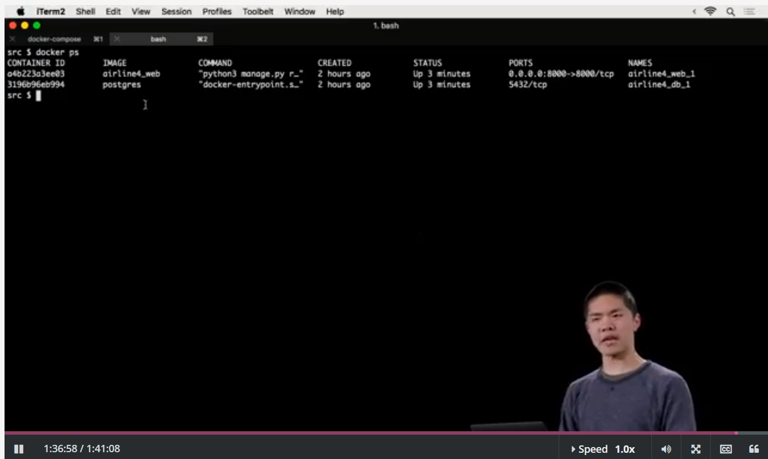

**Coding Challenge Details**

1. Python Program to print the greatest integer in the list without using sort().

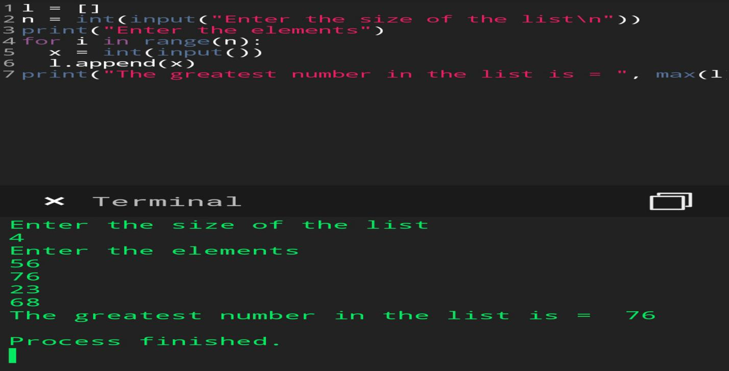

1. Python Program to find digital root of a number.

